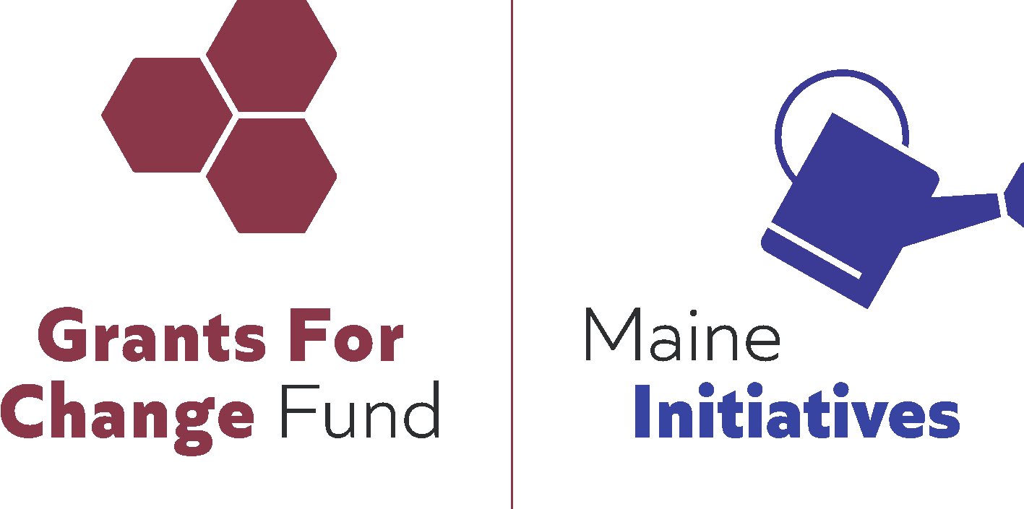

Maine Initiatives is now accepting proposals for the 2022 Grants for Change Program, which seeks to fund and strengthen organizations led by and serving Black, Brown, Indigenous, Latinx, Asian, and People of Color (BIPOC) whose work advances racial justice in Maine. The Grants for Change Program is prioritizing Black and Wabanaki communities in both decision-making and funding for 2022 grantmaking, however, all BIPOC organizations may apply and will be considered for grant awards. Grants awards will not require reporting.

How To Apply

Please follow the process below:

- Check your Eligibility: Please confirm that your organization meets the eligibility criteria in the Request for Proposals found on the Grants for Change webpage [linked here].
- Read the Application: Please read the full application instructions and read the full application (Sections A - G) prior to starting this application. In a commitment to transparency, we are pleased to share the Grant Proposal Evaluation Form the Proposal Readers and Grantmaking Advisory Committee will use to evaluate each proposal, found on the Grants for Change webpage. Please contact the Grants for Change Directors, Desiree and Julian, with any questions at grants4change@maineinitiatives.org or call 207-200-8655. If a translation of the application into a preferred language would be helpful, please contact the Grants for Change Directors to discuss options.

- Attend the Information Session: Please attend the applicant information session on Thursday, September 15, 2022. Please check the Grants for Change webpage for details [linked here]. If you are unable to attend, please watch the recording available on the Grants for Change webpage after the event.

- Complete the Application: Please complete this application using this Microsoft Word Document, or convert this into a Google Doc to complete. We will reformat your application responses, so please do not spend much time with formatting. As long as your responses are clearly identifiable, we can work with it.

- Submit the Application: Please submit your application prior to the deadline as a Google Doc, Microsoft Word Document, or a PDF; please email your completed application (including all required attachments) to grants4change@maineinitiatives.org.

The deadline for applications is Friday, September 30, 2022, by 11:59 pm

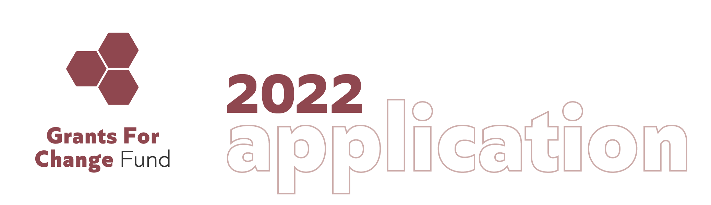

Section A: General Information

This first section asks for general organizational information. Please share the following:

- Organization Name: _____________________________________________________

- Organization’s Mission Statement:

- What is your website address (If not, please share your organization's Facebook or Instagram address):

_____________________________________________________________________

The following questions ask about the people involved in your organization and the partners with whom you work currently:

- Does your organization have paid staff? Yes/No How many?____________

- And/or paid contractors or consultants? Yes/No How many?____________

- And/or regular volunteers/volunteer staff? Yes/No How many?____________

- Is your organization currently working in solidarity with other Black, Indigenous, or other People of Color (BIPOC)-led organizations/groups in Maine, regionally, or nationally? If so, please list up to four of those organizations or groups:

- ________________________________________________________________

- ________________________________________________________________

- ________________________________________________________________

- ________________________________________________________________

- What work (learning or action) are you doing in collaboration with these partners? Please describe these efforts in a few sentences:

- Has your organization received a previous Grants for Change grant award from Maine Initiatives? Yes/No

If yes, please note when, year(s):____________________________________________

Who is the Primary Contact for your organization? (This might be the Executive Director, Board President, or other most prominent public spokesperson.)

Name: ____________________________________________________________

Title: _____________________________________________________________

Office Address: _____________________________________________________

_____________________________________________________

Phone: ____________________________________________________________

Email: _____________________________________________________________

- Who is the Contact Person for this proposal (if different from the person named above)?

Name: ____________________________________________________________

Title: _____________________________________________________________

Office Address: _____________________________________________________

_____________________________________________________

Phone: ____________________________________________________________

Email: _____________________________________________________________

Section B: Organizational Leadership

This section will help our Proposal Readers and Grantmaking Advisory Committee gain a clearer picture of the people closely involved with your organization. The Grant for Change Program funds and strengthens Black, Indigenous, People of Color (BIPOC) community-based, nonprofit organizations working exclusively or primarily in Wabanaki Territory (Maine).

- Do you identify as (please select, with ‘X’, all that apply and use space provided if needed):

___ Black-led,
___ Wabanaki-led, and/or
___ _____________________________________________________________________
___ _____________________________________________________________________

- To be eligible for a 2022 Grants for Change award, applicants are required to meet at least two out of three of the following for at least the past two years*:

- Does your organization have BIPOC key staff leaders of the organization - 50% or more of the total in leadership roles? Yes / No
- Does your organization have BIPOC members on the Board of Directors - 50% or more in governing decision-making roles? Yes / No
- Does your organization have BIPOC activists - 50% or more on the ground, community organizers, staff/volunteers? Yes / No
* If your organization does not meet all three because of intentional strategic or equity considerations made by BIPOC decision-makers within the organization, please explain below:

________________________________________________________________________

________________________________________________________________________

________________________________________________________________________

- Please provide the names and titles or roles of leaders in your organization below:

Name: ____________________________________________________________

Title: __________________________________________________________

Name: ____________________________________________________________

Title: __________________________________________________________

Name: ____________________________________________________________

Title: __________________________________________________________

Section C: The Narrative Proposal

This proposal narrative is your opportunity to share more about your organization and your community-based efforts in Maine. Please read and then answer all (4) four of the following questions. You may answer the questions in any order you choose. If you have questions or concerns about any of the following questions, please contact the Grants for Change Directors, Desiree and Julian, at grants4change@maineinitiatives.org or call 207-200-8655 to discuss.

Please write no more than three (3) pages total, preferably, single-spaced with 12-point font.

- Please describe your organization's overall purpose in relation to the impact, change, or transformations you seek to make through your organization’s efforts.

- In the past 12 months, in what ways have your community efforts contributed toward racial justice or racial equity in Maine, including (but not limited to): community advocacy, community building, movement organizing, vital cultural practice, and/or community healing?

- How, or in what ways, does your organization take care of the people in your community who take care of the people in your community? In other words, how does your organization practice care for caregivers? Please share a story or two to illustrate, if possible.

- What are the three (3) most important things for other people–who are similarly committed to racial justice in Maine–to know about your organization?

Section D: Community Effort Areas, Roles, or Pathways
This section will help our Maine Initiatives Staff and Board, Proposal Readers, and Grantmaking Advisory Committee better understand the various areas, roles, or pathways your organizational efforts live in. This funding priorities framework was created out of deep conversation, experience, and knowledge of community efforts and needs over the past years.
The purpose of this framework is to challenge our Grantmaking Advisory Committee, funding partners and peers, and the general public to recognize and support the broad array of racial justice work critical for a robust, effective, and sustainable ecosystem. The designations are not exclusive nor are they exhaustive; many applicant organizations will identify with several of the areas, roles, or pathways of Hub, Community Building, and Emergent Organizations.
Please select (with ‘X’) all the areas, roles, or pathways that your work lives in that apply from the following. You can add others that best describe your organization's work, efforts, and priorities in the blank spaces provided. At the bottom, please explain why you chose the areas in a few sentences.

Hub Organizations - These organizations might be or have:
___ Relatively more established (compared with other BIPOC-led or -serving organizations in Maine) with higher visibility to the general public
___ Developed access to resources or established funding sources and relationships
___ Sufficient capacity to provide resources or platforms for other BIPOC-led organizations
___ Working across race and class identities or across geographic communities
___ Working at the institutional or structural level counter and dismantle expressions of racial injustice, racial inequity, and white supremacy (advocacy or policy work, for example)
___ Annual budgets over $250,000, approximately
___ ___________________________________________________________
___ ___________________________________________________________

Community Building - These organizations might be or have:
___ Smaller organizations (with fewer staff, smaller budget) that are not as visible or well-known in the broader community or to the general public, either by choice or because of structural barriers
___ Focused on direct service or community support, mutual aid efforts, or grassroots organizing (base-building, for example)
___ Offering community or individual healing work being done to respond to the trauma, harms, and legacies of slavery and colonization (harm reduction or communal healing ceremonies or sessions, for example)
___ Working at cultural or systems levels, including arts and other forms of creative activity
___ Focused on sustaining communal systems outside of dominant systems of oppression
___ Land-access, Land-back, Land-based work, food justice, community food and medicine
___ Annual budgets under $250,000, approximately
___ ___________________________________________________________
___ ___________________________________________________________

Emergent Organizations - These organizations might be or have:
___ Newer and/or emerging community-based organizations, typically in first year or two of existence
___ Underfunded, under-recognized, under-supported (in terms of staffing & organizational structure), under-resourced, and perhaps less visible to traditional funders and/or the general public
___ Systematically excluded from resources or funding relationships
___ Staffed by a few people, often in volunteer capacity
___ Applying for first grant and/or seeking fiscal sponsorship
___ Annual budget under $25,000, approximately
___ ___________________________________________________________
___ ___________________________________________________________

Please explain why you chose the areas, roles, or pathways you did in a few sentences:

Section E: Legal/Fiscal Organization

This section is needed for the fiscal administration of any grants made by Maine Initiatives. Maine Initiatives does directly fund organizations that do not have official 501(c)(3) status, but any such applicants will need to obtain a fiscal sponsor or sponsorship by a Tribal entity before the Grantmaking Advisory Committee’s retreat in mid-November 2022.
- Is this application presented on behalf of a Tribal government or tribal entity? Yes / No
If yes, please indicate the Tribal government or other entity:

____________________________________________________________________
- Does your organization have 501(c)(3) status? Yes / No

- If you do not have your 501(c)(3) status, please name your Fiscal Sponsor (if you have one)?

__________________________________________________________________________

- If you do not yet have a Fiscal Sponsor, would you like assistance with locating a potential Fiscal Sponsor? Yes / No

- What is your Organizational EIN or the EIN of your Fiscal Sponsor? (if you have one)

___________________________________________________________________________

Section F: Organizational Budget

This section requests general budgetary information about your organization. A review of your budget will help our Grantmaking Advisory Committee members better understand the fiscal health of your organization, your financial need, and your funding model.

- Please provide a breakdown of your operating income and expenses (Budget) for your most recently completed fiscal year. If this is your first year, please submit a current budget.
- You may attach your own spreadsheet, you may use a budget document from another foundation’s application, or you may use the Organizational Budget Template format provided on the next page.
- The Organizational Budget Template is offered only for reference and if needed. The budget line items listed in the template provided are examples (Individual Contributions, Fundraising Expenses, etc.) You may include more, less, or other line items in the budget you provide.
- For definitions or explanations of some of the financial terms used in the template provided, please see the Glossary of Terms from ABC, ‘A Bookkeeping Cooperative’, “a worker-owned union cooperative dedicated to building solidarity economies”.
- If you have questions about this budget request, please contact the Grants for Change Directors, Desiree and Julian, at grants4change@maineinitiatives.org or call 207-200-8655.

Organizational Budget Template (use if needed)

Budget Start Date: _______________________ Budget End Date: _____________________

Income Type | Budgeted  Amount | Actuals Amount | Notes
Government Grants/Contracts
Foundation and Corporate Grants
(please list names and amounts in Notes field)
Individual Contributions
Earned Income
(please specify in Notes field)
In-Kind Support
(please specify in Notes field)
Other Income
(please specify in Notes field)
Income Total

Expense Type | Budgeted Amount | Actuals Amount | Notes
Program Expenses
Staff Salaries
Administrative Expenses
Fundraising Expenses
Other Expenses: _______________________
Other Expenses: _______________________
Other Expenses: _______________________
Expense Total

Section G: Anything Else? (Optional)

On no more than one (1) additional page, please share with us anything you wish we would have asked about but didn’t or anything else that will help our Proposal Readers and Grantmaking Advisory Committee make their decisions.

Links to videos, photos, charts, graphs, or newspaper and blog post links are all appropriate to include here. Please note that no additional supplemental materials are allowed beyond this page.

- Would you like to attach videos, photos, charts, graphs, and/or newspaper or blog post links? Yes / No

If yes, please include links below, or send them to grants4change@maineinitiatives.org.

Links:

- How, if at all, would you like the general public to engage with your organization and support your work right now, including but not limited to financial support? (Examples might include: sharing events on social media or through networks, volunteering time, donating funds, gifting supplies, educating self about particular issues, etc.)

